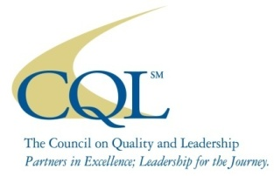
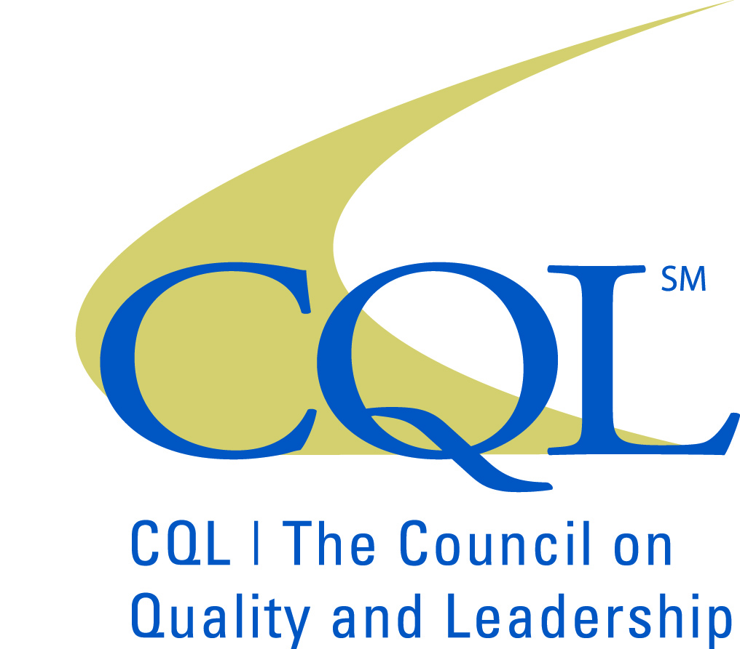
CQL
Accreditation
Request for Engagement

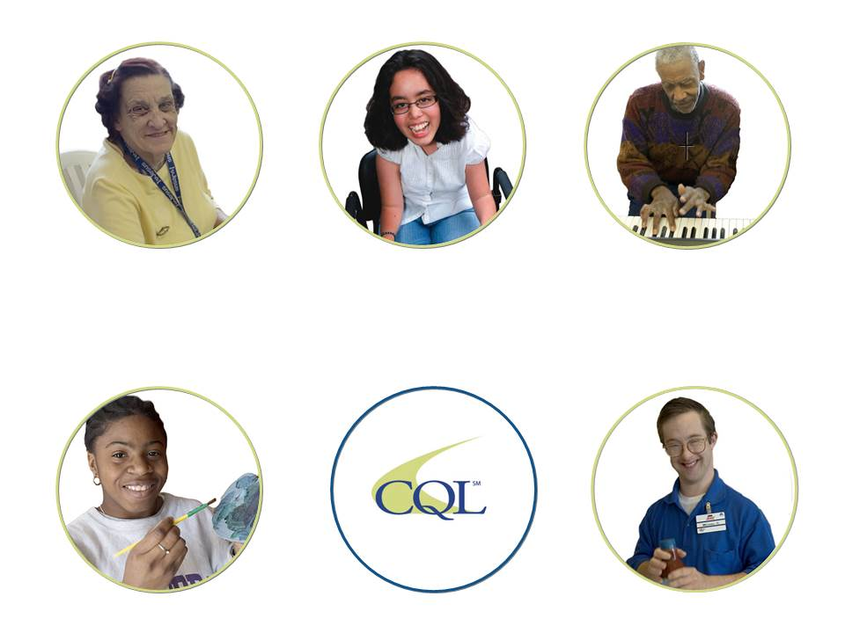

Questions:

Please contact Becky Hansen, Vice President of Accreditation and Training, at bhansen@thecouncil.org or 605.743.4442.

Section One

Identifying Information
Organization:
Address:
City:
State:
Zip:
Telephone:
Fax:

Chief Executive Officer/Executive Director/Owner
Name:
Title:
Phone:
E-mail Address:

Organization Contact (Primary contact for coordination):
Name:
Title:
Phone:
E-mail Address:

Billing
Contact name:
Address (if different from above):
Phone:
E-mail Address:

Scheduling Preference: (must have at least 3 months for preparation)
1st Choice:
2nd Choice:
3rd Choice:
Please list any weeks during these months that are unavailable for the review:

Types of Services Provided by the Organization

Please check all that apply:

Direct and/or support services for young children and their families (ages 0-5).

Direct and/or support services for children and youth (ages 6-18).

Direct and/or support services for adults (ages 19 and above) with disabilities.

Direct and/or support services for adults (ages 19 and above) with behavioral health issues as
their primary diagnosis.

Service coordination/Case Management services for young children and their families
(ages 0-5)

Service coordination/Case Management services for children and youth (ages 6-18).

Service coordination/Case Management services for adults (ages 19 and above)

Other services not falling under these categories (describe briefly):

Information About People Served by the Organization

Please indicate the number of people served by the organization in each of the categories listed.
 | Below  Age 6 | Age  6-18 | Age  19-55 | Over  Age 55 | TOTAL
Male
Female
Total

Organization’s Operating Budget

Please Select:

$0 - $1,000,000

$1,000,001 - $2,500,000

$2,500,001 - $5,000,000

$5,000,001+

Section Two

Selection of Desired Accreditation

Please select the accreditation model that best suits the needs of your organization from the options below. Please note that the accreditation model selected for your organization must be approved by CQL.

Descriptions of the accreditation models can be found in Addendum A (attached).

CQL Systems Accreditation

CQL Quality Assurances Accreditation

CQL Person-Centered Excellence Accreditation

CQL Person-Centered Excellence Accreditation with Distinction Accreditation

Section Three

Additional Information

In addition to the completion of all forms, please submit the following information:

Is your organization currently accredited by CQL?

Has your organization changed names, merged, split, or otherwise structurally changed since the last review? If so, please check box and clearly identify those changes.

Comments:

Please include your organization’s Mission Statement--Values and Vision Statements here.

Please provide an organizational biography and expectations for CQL Accreditation.

Please describe the organization’s exposure, if any, to the Personal Outcome Measures®.

Does the organization currently utilize CQL’s Personal Outcome Measures®:

If Yes:
- Describe the information gathering process and how data is collected and analyzed.

- Describe how information gleaned from Personal Outcome Measures® is used at your organization (i.e. individual discovery and planning, organizational evaluation and planning, etc.)

Does your organization have any Certified Personal Outcome Measures® Trainers or Interviewers employed at your organization?

If yes, please list all Certified Personal Outcome Measures® Trainers or Interviewers currently employed at the organization.

Comments:

Section Four

Certification of Compliance (to be submitted with the Request for Engagement)

Organization Name:
Address:
CEO Name:
Phone:
I certify that (org name) is in compliance with all required local, state, and federal regulations relevant to the supports and services we provide including:
- Licensing and certification requirements;
- Sanitation/fire and safety codes;
- Reporting compliance for incidents, abuse and/or neglect; and
- Any other that may apply.

I affirm that there are no current open or unresolved issues related to:
- Outstanding fiscal or legal sanctions;
- Non-compliance with regulations;
- Licensing exceptions;
- Unfavorable third party reviews;
- Abuse, neglect, or other circumstances being investigated by local, state or federal entities; and
- Any related circumstances that require a plan of correction in order to remain licensed, certified, or funded.

I confirm that we have:
- current external monitoring reports and responses for all services and supports provided;
- current external monitoring reports and responses for all licensed buildings showing that all required safety/compliance standards are met;
- clear policies that state the procedures for meeting local, state, funding, and federal requirements;
- current plans of correction showing all outstanding issues have been (or are being) addressed.

I agree to provide completed copies of evidence of compliance for any external monitoring reports and if appropriate, approved corrective plans to CQL as requested.

Name (type or print): Date:

CEO Signature:
If you are submitting this form electronically, please type name above and check this box to confirm that this emailed document is a binding agreement without the actual signature of the Chief Executive Officer.

OR, you may print this page, sign, and fax to 850-270-3618.

Section Five

List of Organization Leadership staff:

Purpose:
This list will be used to coordinate a Pre-engagement Planning Call which is designed to provide the organization’s leadership staff with information about the accreditation process, preparation activities and responsibilities.

# | NAME | TITLE | PHONE | EMAIL ADDRESS
1
2
3
4
5
6
7
8
9
10
11
12
13
14
15

Section Six

Travel Advice for CQL Team

Airport Information

Nearest Major Airport:
Distance from Organization (miles):

Lodging Information
Hotel/Motel | City | Telephone | Distance to Organization

Section Seven

Engagement Agreement

The undersigned hereby agrees to work with CQL | The Council on Quality and Leadership for CQL accreditation and/or related activities, agrees to pay the established fee, and grants permission to licensing agencies and any other relevant examining or reviewing entity or group to release official records and information to CQL for its consideration during the accreditation process.

Upon receipt, CQL will process this request and set dates for the initial accreditation. In the event that the scheduled accreditation is canceled or postponed by the organization, the organization is responsible for payment of any expenses incurred by CQL.

Organization Name:

Signature of Chief Executive Officer:

Date:

If you are submitting this form electronically, please type name above and check this box to confirm that this emailed document is a binding agreement without the actual signature of the Chief Executive Officer.

Section Eight

Checklist
(to be completed by the organization)

All sections that apply are completed

CEO signature or electronic signature box is checked as confirmation of Certification of Compliance and Engagement Agreement

Submit form:

Electronically to: jsundem@thecouncil.org

By mail: CQL | The Council on Quality and Leadership
POB 2296, Pensacola, FL 32513-2296

By fax: 850-270-3618

Engagement fee of $2500 (NON-REFUNDABLE)
Pay by check – include with form.

Pay by credit card via Pay Pal. You do not need a Pay Pal account to use Pay Pal. Click or cut and paste this link. http://www.c-q-l.org/payaccreditationfees.aspx

Pay by credit card. Please call Marie Johnson to provide credit card information at 850-712-2367. Please do not email credit card information.

Next Steps

You will receive a Letter of Engagement with the onsite dates and cost of accreditation along with a Preparation Packet once the request has been processed.
Addendum A: Accreditation Model Descriptions

CQL Systems Accreditation
Term | Criteria To Achieve Accreditation | Intended For
1 year | - Completed Basic Assurances® and Shared Values Self Assessments by Organization  - CQL validation of 100% Compliance with Shared Values and applicable systems related to Basic Assurances®  NOTE: Once services have been initiated, the organization must apply for CQL Basic Assurances® Accreditation | - Organizations not yet providing direct services

CQL Quality Assurances® Accreditation
Term | Criteria To Achieve Accreditation | Intended For
3 years | - INITIAL VISIT-ONSITE: Completed Basic Assurances® and Shared Values Self Assessments by Organization  - CQL validation of 100% Compliance with Shared Values and applicable Basic Assurances®  - Successful implementation of the accreditation partnership agreement, including implemented of correction completed within 9 months (if applicable) for any Basic Assurances® not present during initial visit  - SECOND VISIT-ONSITE: Completed Responsive Services and Community Life Self Assessments by Organization  - CQL validation of implementation of Personal Outcome Measures® on an individual and organizational level  - CQL validation of implementation of recommendations from first visit and 100% Compliance with applicable Responsive Services and Community Life Indicators  - CQL validation of the implementation of an integrated quality management plan including Personal Outcome Measures® data  NOTE: CQL reserves the right to require a third onsite visit if criteria is not met | - Organizations new to CQL or those wanting to enhance systems and practices related to health, safety and human security  - Organizations dedicated to Responsive Services and Community Life  - Organization’s committed to improving personally defined quality of life through the implementation of CQL’S Personal Outcome Measures®

CQL Person-centered Excellence Accreditation
Term | Criteria | Intended For
4 years | - INITIAL VISIT-ONSITE: Completed Basic Assurances® and Shared Values Self Assessments by Organization  - CQL validation of 100% Compliance with Shared Values and applicable Basic Assurances®  - Successful implementation of the accreditation partnership agreement, including implemented plan of correction completed within 9 months (if applicable) for any Basic Assurances® not present during initial visit  - CQL validation of implementation of Personal Outcome Measures® on an individual and organizational level  - CQL facilitation of Person-centered Excellence stakeholder group and What Really Matters plan development  SECOND VISIT-OFFSITE:  - CQL validation of implementation of recommendations from first visit and of progress made on What Really Matters plan shorter range goals  THIRD VISIT-OFFSITE:  - CQL validation of implementation of recommendations from second visit and of progress made on What Really Matters plan longer range goals  - CQL validation of ongoing implementation and enhancement of an organizational integrated quality management system | - Organizations wanting to focus on health, safety and human security  - Organizations dedicated to responsive services and community of life  - Organizations currently implementing CQL’S Personal Outcome Measures®  - Organizations with an established integrated quality management system (Refer to Basic Assurances® Factor 10 for details) that incorporates Personal Outcome Measures® data  - Organizations committed to engaging stakeholders in the development and implementation of an organizational plan focused on What Really Matters to people

CQL Person-centered Excellence with Distinction Accreditation
Term | Criteria To Achieve Accreditation | Intended For
4 years | - INITIAL VISIT-ONSITE: Completed Basic Assurances® and Shared Values® Self Assessments by Organization  - CQL validation of 100% Compliance with Shared Values® and applicable Basic Assurances®  - Successful implementation of the accreditation partnership agreement, including implemented plan of correction completed within 9 months (if applicable) for any Basic Assurances® not present during initial visit  - CQL validation of implementation of Personal Outcome Measures® including the use of CQL certified reliable interviewers/trainers  - Minimum of 10% Personal Outcome Measures® sample collected by organization required each year and included in CQL data base  - Agency-led facilitation of Person-Centered Excellence stakeholder group and What Really Matters plan development (with support from CQL)  SECOND VISIT-OFFSITE:  - CQL validation of implementation of recommendations from first visit and of progress made on What Really Matters plan shorter term goals  THIRD VISIT-OFFSITE:  - CQL validation of implementation of recommendations from second visit and of progress made on What Really Matters plan longer range goals  - CQL validation of ongoing implementation and enhancement of an organizational integrated quality management system that incorporates reliable Personal Outcome Measures® data | - Organizations wanting to focus on health, safety and human security  - Organizations dedicated to responsive services and community of life  - Organizations committed to improving personally defined quality of life through the implementation of CQL’S Personal Outcome Measures®  - Organizations with demonstrated internal capacity for collecting reliable data via currently CQL certified interviewers/trainers  - Organizations with an established integrated quality management system (Refer to Basic Assurances® Factor 10 for details) that incorporates reliable Personal Outcome Measures® data  - Organizations committed to taking a lead role in engaging stakeholders in the development and implementation of an organizational plan focused on What Really Matters to people
NOTE: If applying for Person-Centered Excellence with Distinction, please submit a copy of your current integrated quality management plan and corresponding data along with your Request for Engagement.

Return to Selection of Desired Accreditation

